Faculty of Engineering, Architecture and Science
Department of Mechanical, Industrial, and Mechatronics Engineering

Program | Electrical Engineering
Course Number | ELE754
Course Title | Power Electronics
Semester/Year | F2025
Instructor | Dr. David Xu

Lab/Tutorial Report NO. | Tutorial (1)

Report Title | Lab-Volt Power Converter and Data Acquisition Platform

Section No. | 02
Submission Date | September 27, 2025
Due Date | September 28, 2025

Name | Student ID | Signature*
Shai Mourad | 501170415

*By signing above you attest that you have contributed to this submission and confirm that all
work you have contributed to this submission is your own work. Any suspicion of copying or
plagiarism in this work will result in an investigation of Academic Misconduct and may result
in a “0” on the work, an “F” in the course, or possibly more severe penalties, as well as a
Disciplinary Notice on your academic record under the Student Code of Academic Conduct,
which can be found online at:
https://www.torontomu.ca/senate/policies/pol60.pdf.

Table of Contents
Introduction 2
Objectives 2
Procedure 2
Output (Waveforms) 2
Data 7
Discussion 8
Conclusion 9
References 9

Introduction
The tutorial laboratory introduces a Lab-Volt electric power technology platform, data acquisition software (LVDAC-EMS), and measurement instrumentation (digital multimeter and oscilloscope). Focusing on AC and DC signals the experiment focuses on different load and converter measurements, observing the relationship between input and output (based on knob position or duty cycle). This lab’s focus is to compare the results of both the software and hardware-based measurements and compare them for accuracy and consistency.

Objectives
The objective of this tutorial is to become familiar with Lab-Volt Power Converters and Data Acquisition Platforms. Measuring AC voltage and current using LVDAC-EMS software with both a digital multimeter (DMM) as well as an oscilloscope is conducted using the aforementioned technology. Also, the lab studies a PWM buck chopper and records voltage/current at different duty cycles. All values/observations obtained are compared from software and hardware instruments.

Procedure
Experiment 1:
A variable AC supply is connected to a 120 Ω resistor and 50 mH inductor. Measurements of voltage and current were taken via LVDAC-EMS software at knob positions 25%, 50%, 75%, and 100%..

Experiment 2:
Using the same circuit as “Experiment 1”, measurements are taken using a DMM (voltage) and oscilloscope (current). Waveforms are captured using the oscilloscope.

Experiment 3:
A PWM buck converter is connected to a 120 Ω resistor and 2 mH inductor. Measurements were taken via LVDAC-EMS + oscilloscope software at duty cycles 10%, 30%, 50%, 70%, and 90%.

Output (Waveforms)

Experiment 1 – LVDAC-EMS (AC Measurements)
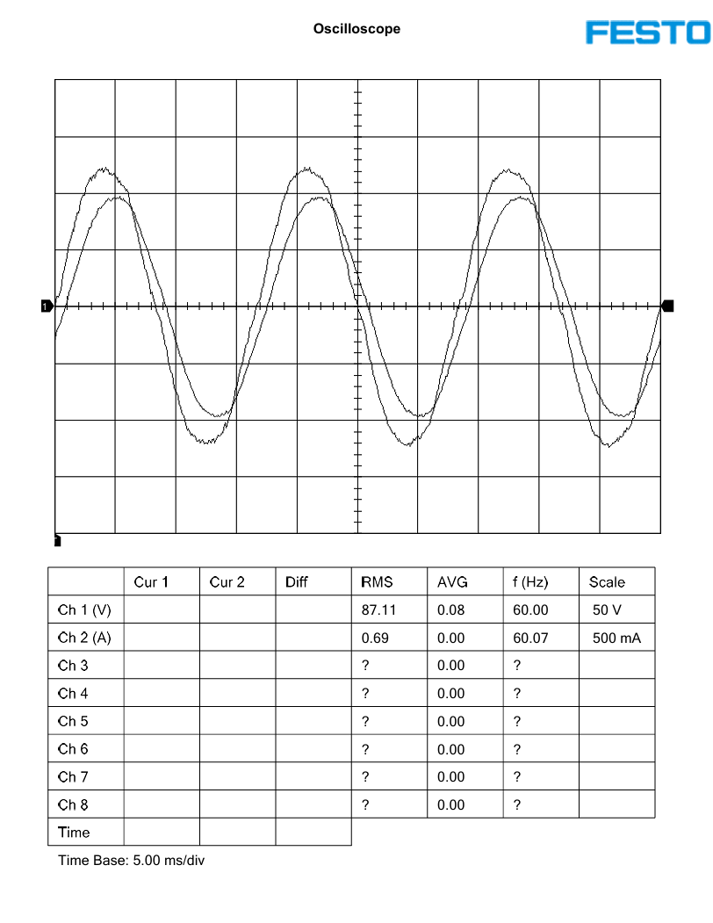
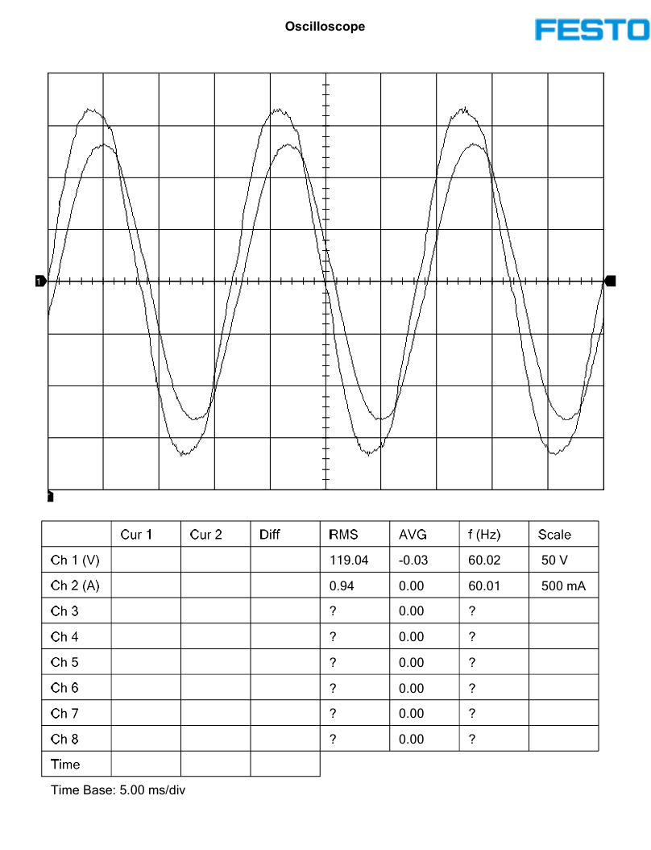
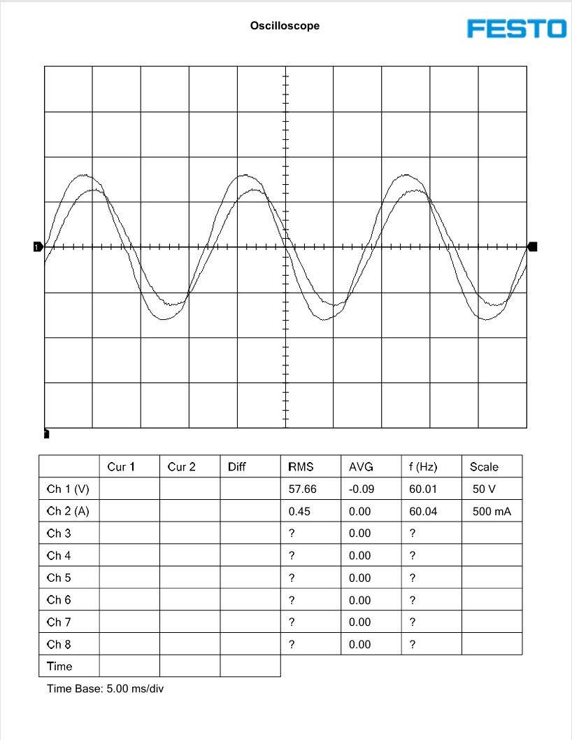
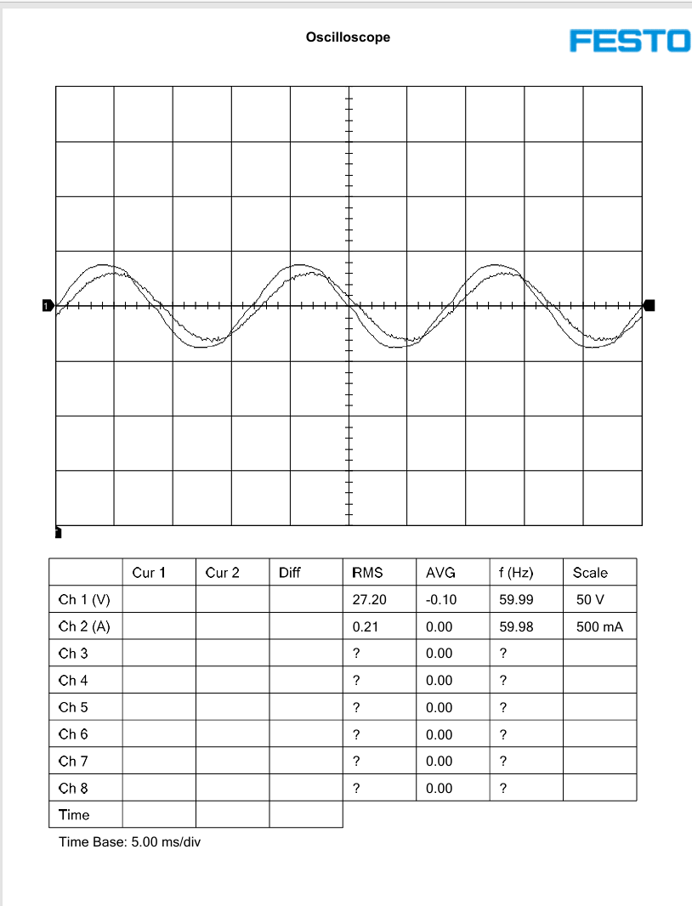
Figure 1.1 – Voltage and Current Waveforms at 25% Knob | Figure 1.2 – Voltage and Current Waveforms at 50% Knob
Figure 1.3 – Voltage and Current Waveforms at 75% Knob | Figure 1.4 – Voltage and Current Waveforms at 100% Knob

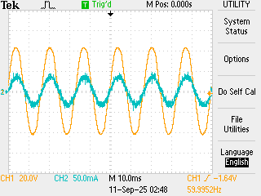
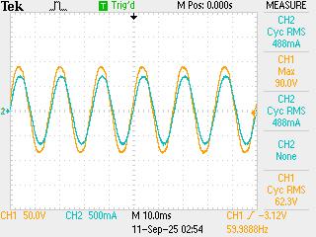
Experiment 2 – DMM & Oscilloscope (AC Measurements)
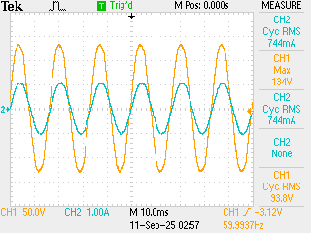
Figure 2.1 – Voltage and Current Waveforms at 25% Knob | Figure 2.2 – Voltage and Current Waveforms at 50% Knob
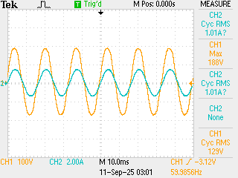
Figure 2.3 – Voltage and Current Waveforms at 75% Knob | Figure 2.4 – Voltage and Current Waveforms at 100% Knob

Experiment 3 – PWM Buck Chopper (LVDAC-EMS)

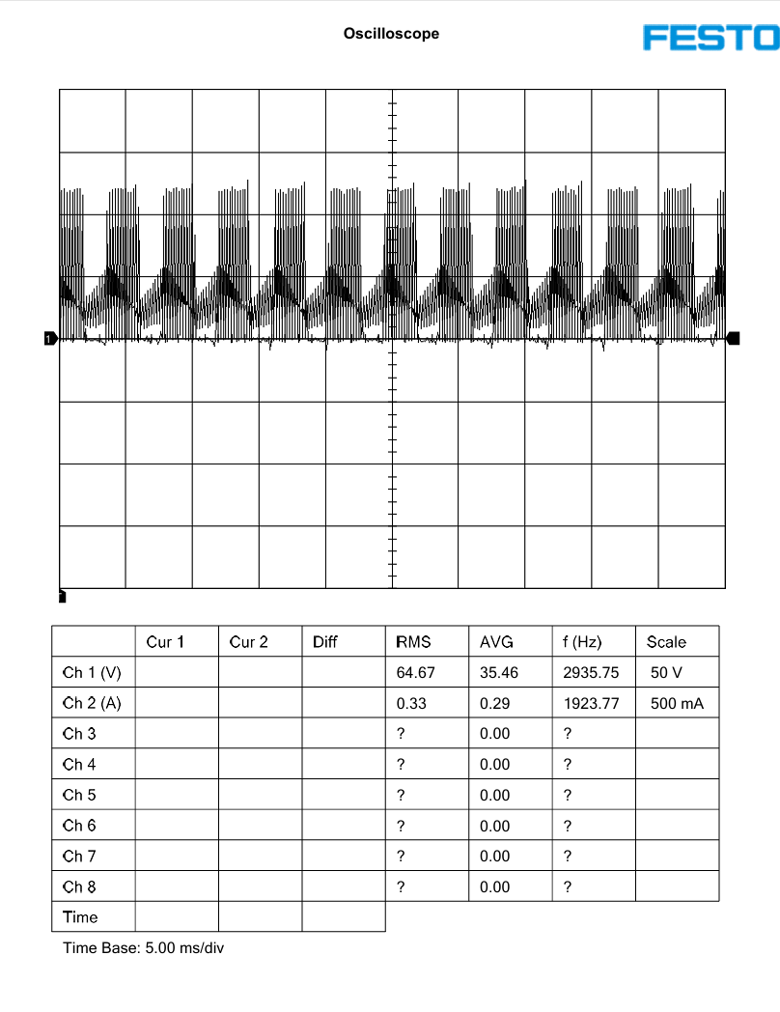
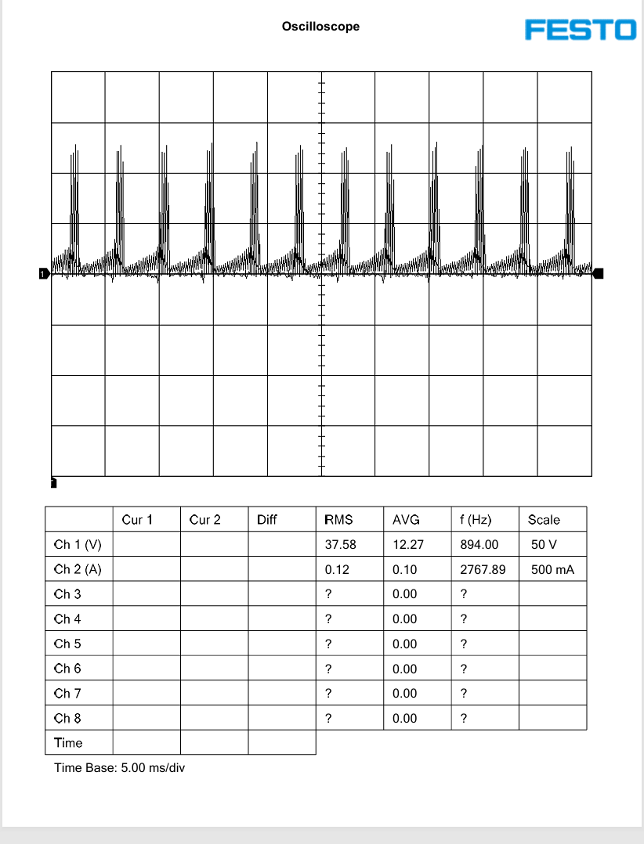
Figure 3.1 – Voltage and Current Waveforms at 10% Duty Cycle | Figure 3.2 – Voltage and Current Waveforms at 30% Duty Cycle
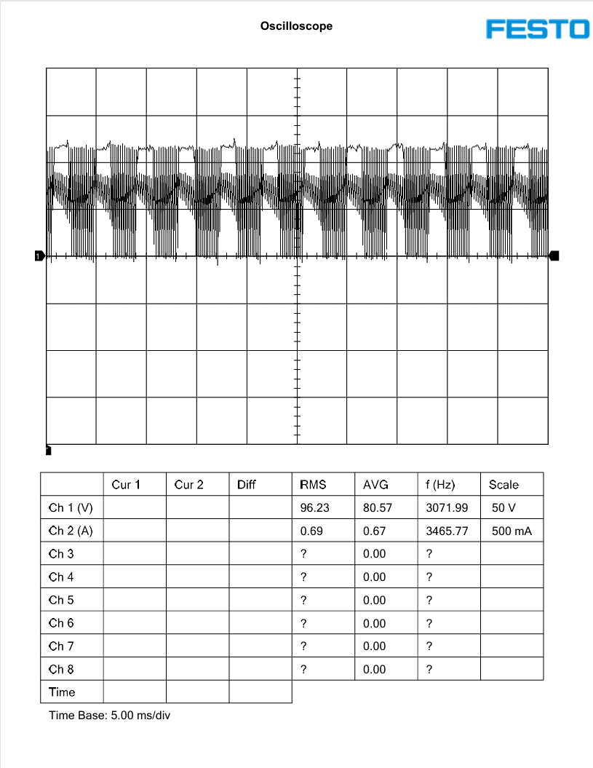
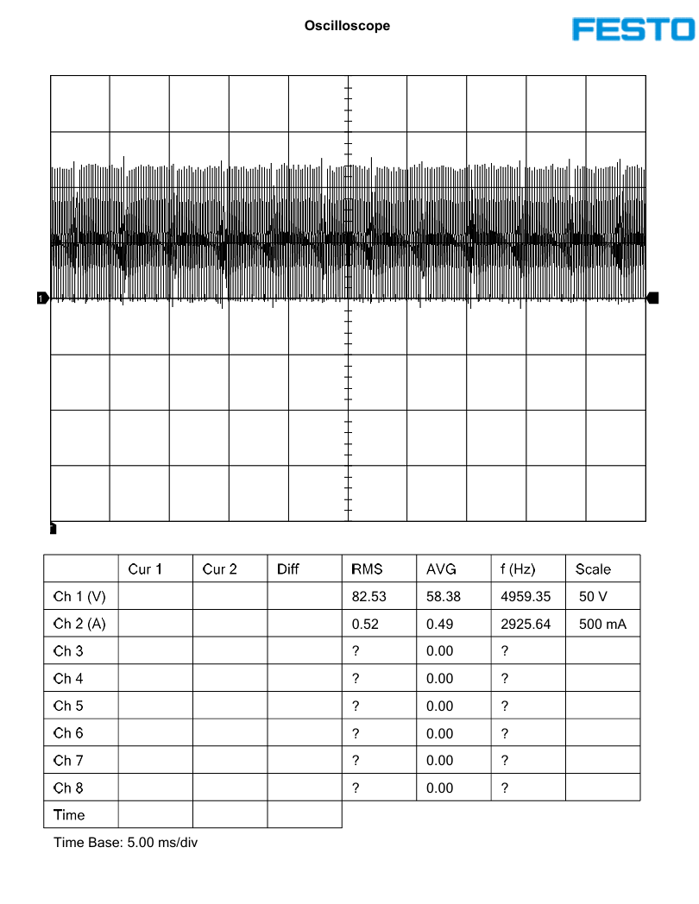
Figure 3.3 – Voltage and Current Waveforms at 50% Duty Cycle | Figure 3.4 – Voltage and Current Waveforms at 70% Duty Cycle

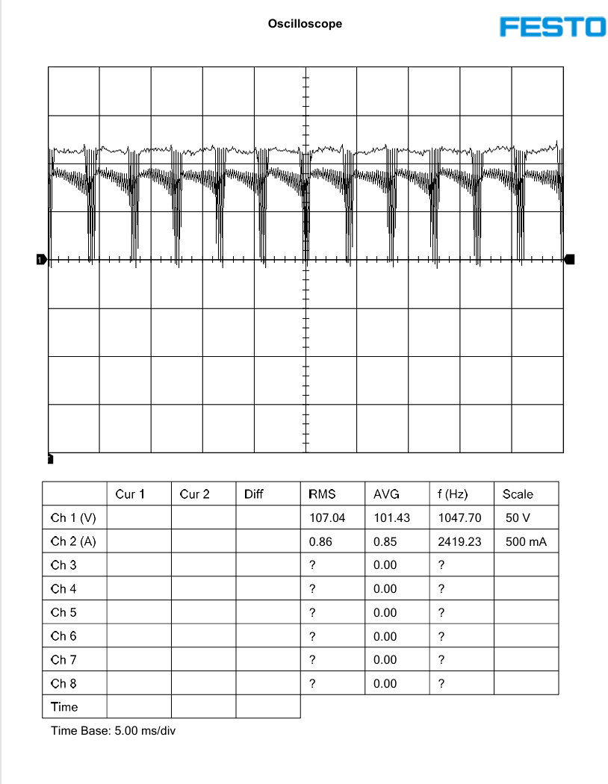
Figure 3.5 – Voltage and Current Waveforms at 90% Duty Cycle

Experiment 3 – PWM Buck Chopper (DMM & Oscilloscope)
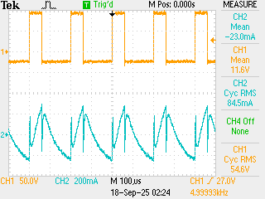
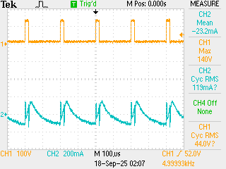
Figure 3.6 – Voltage and Current Waveforms at 10% Duty Cycle | Figure 3.7 – Voltage and Current Waveforms at 30% Duty Cycle

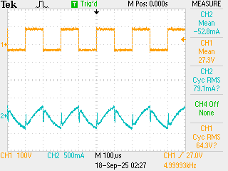
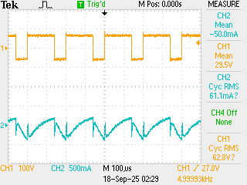
Figure 3.8 – Voltage and Current Waveforms at 50% Duty Cycle | Figure 3.9 – Voltage and Current Waveforms at 70% Duty Cycle

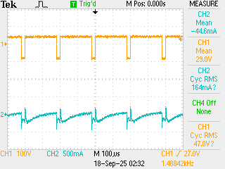
Figure 3.10 – Voltage and Current Waveforms at 90% Duty Cycle

Data

Experiment 1 – LVDAC-EMS Experiment 2 – DMM & Oscilloscope
Knob | Voltage (V) | Current (A)
25% | 30.6 | 0.253
50% | 62.5 | 0.480
75% | 93.7 | 0.745
100% | 129.0 | 1.01

Knob | Voltage (V) | Current (A)
25% | 27.17 | 0.215
50% | 57.65 | 0.453
75% | 86.90 | 0.687
100% | 118.9 | 0.940

Experiment 3 – LVDAC-EMS Experiment 3 – DMM & Oscilloscope
Duty Cycle | Voltage (V) | Current (A)
10% | 11.2 | 0.022
30% | 34.5 | 0.0255
50% | 57.12 | 0.059
70% | 79.15 | 0.065
90% | 100.4 | 0.051

Duty Cycle | Voltage (V) | Current (A)
10% | 11.76 | 0.121
30% | 33.25 | 0.331
50% | 56.51 | 0.520
70% | 82.61 | 0.692
90% | 106.8 | 0.859

Discussion
Both “Experiment 1 & 2” show near-linear increase in voltage and current with knob position. DMM/oscilloscope readings were consistently slightly higher than LVDAC-EMS values (e.g., at 100%, 118.9 V vs. 129 V); these differences may stem from calibration and measurement resolution. “Experiment 3”. LVDAC-EMS measurements were observed to be proportional with increases in both voltage and current with duty cycle. DMM/oscilloscope measurements match for voltage but showed much lower current values compared to LVDAC-EMS. The discrepancy in current was due to a malfunctioning oscilloscope. Both experiments were consistent with theory learned in lectures.

Conclusion
This lab properly demonstrated the usage of software-based (LVDAC-EMS) and hardware-based (DMM/oscilloscope) measurement systems for AC and DC circuits. Voltage and current properly changed due to altering probe or duty cycle values. Even though all experiments showed proper trends, an oscilloscope malfunction resulted in improper measurements for experiment 3. This highlights the importance of reliable and up-to-date technology for experiments in the electrical engineering field.

References
References
Toronto Metropolitan University. (n.d.). Lab-Volt Power Converter and Data Acquisition Platform [PDF]. D2L. https://courses.torontomu.ca/d2l/le/content/1064952/viewContent/6627400/View

